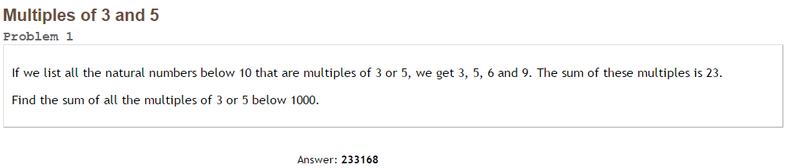Project Euler #1 – Pen & Paper Solution

Using "Inclusion-Exclusion Principle”.

A - Sum of all multiples of 3.

B - Sum of all multiples of 5.

C – Sum of all multiples of 15.

Answer = (A + B) – C



501*333 + 500*199 – 1005*33 = [233168](http://www.wolframalpha.com/input/?i=501*333+%2B+500*199+%E2%80%93+1005*33+)